Integrity Constraints
- Integrity constraints are a set of rules. It is used to maintain the quality of information.
- Integrity constraints ensure that the data insertion, updating, and other processes have to be performed in such a way that data integrity is not affected.
- Thus, integrity constraint is used to guard against accidental damage to the database.

Types of Integrity Constraint
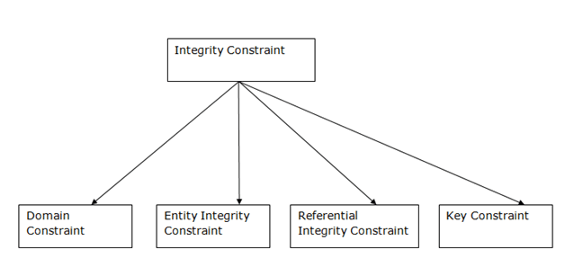

1. Domain constraints
- Domain constraints can be defined as the definition of a valid set of values for an attribute.
- The data type of domain includes string, character, integer, time, date, currency, etc. The value of the attribute must be available in the corresponding domain.

Example:
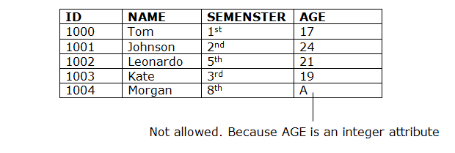

2. Entity integrity constraints
- The entity integrity constraint states that primary key value can't be null.
- This is because the primary key value is used to identify individual rows in relation and if the primary key has a null value, then we can't identify those rows.
- A table can contain a null value other than the primary key field.
Example:
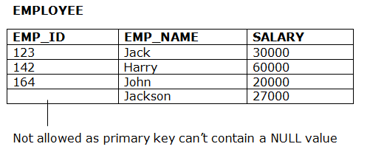

3. Referential Integrity Constraints
- A referential integrity constraint is specified between two tables.
- In the Referential integrity constraints, if a foreign key in Table 1 refers to the Primary Key of Table 2, then every value of the Foreign Key in Table 1 must be null or be available in Table 2.
Example: 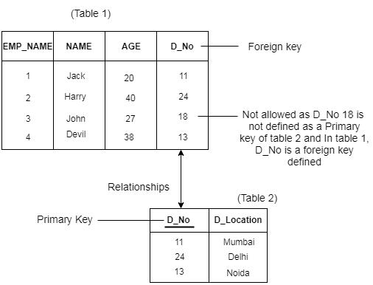

4. Key constraints
- Keys are the entity set that is used to identify an entity within its entity set uniquely.
- An entity set can have multiple keys, but out of which one key will be the primary key. A primary key can contain a unique and null value in the relational table.
Example:
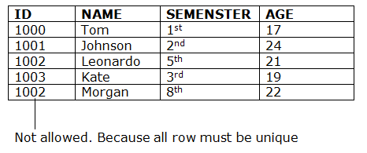

Disjoint Constraint VS Overlap constraint
- In disjoint constraint, an entity cannot belong to more than one lower-level entity sets.
- In overlapping constraint, same entity can belong to more than one lower-level entity sets. For example: a manager can participate in more than one project.
- Example: Consider a super class 'musician'. Two sub classes are 'singer' and 'guitar player'.
In disjoint constraint, you have to put musician in any one sub classes. In overlapping constraint, the musician can be put in both.

The disjoint rule states an entity instance of a supertype can only be a member of one subtype. The overlap rule states an entity instance of a supertype can be a member of multiple subtypes.
Example of disjoint rule: Instance of Super-type Animal can only be member of exactly one of these Sub-types being Panda, Cheetah and Dog Disjoint Union , (An animal can either be Panda or be Dog or be Cheetah but can't be any two or more at the same time)
Example of overlap rule: Instance of Super-type Person can be member of multiple Sub-types being Woman, Driver and Engineer Overlapping Union , (A person can be a Woman and that same Woman can be Driver and that same Woman can be Engineer at the same time)

